Academic Year: 2025-26 | Year: Third Year | Term: II
PRN No.: 1012412002 | Name: Sanket Devkar
Subject: Cloud Computing
Assignment No.: 02
Date: 23-12-2025

Lab Assignment: 02
Title: Research and present a detailed overview of cloud computing, including its definition, characteristics, and advantages compared to traditional IT infrastructure. Explore the cloud concepts and a case study which mentions advantages compared to traditional IT infrastructure.

Theory

1.1 Definition of Cloud Computing
Cloud computing refers to the practice of using a network of remote servers hosted on the internet to store, manage, and process data, instead of relying on local servers or personal computers. This technology has revolutionized the way businesses and individuals interact with information systems by providing scalable, flexible, and on-demand resources.
Cloud computing allows users to access computing resources like applications, data storage, and networking through the internet. Instead of purchasing physical hardware, organizations rent these resources from cloud service providers, allowing for greater flexibility, lower upfront costs, and better scalability.

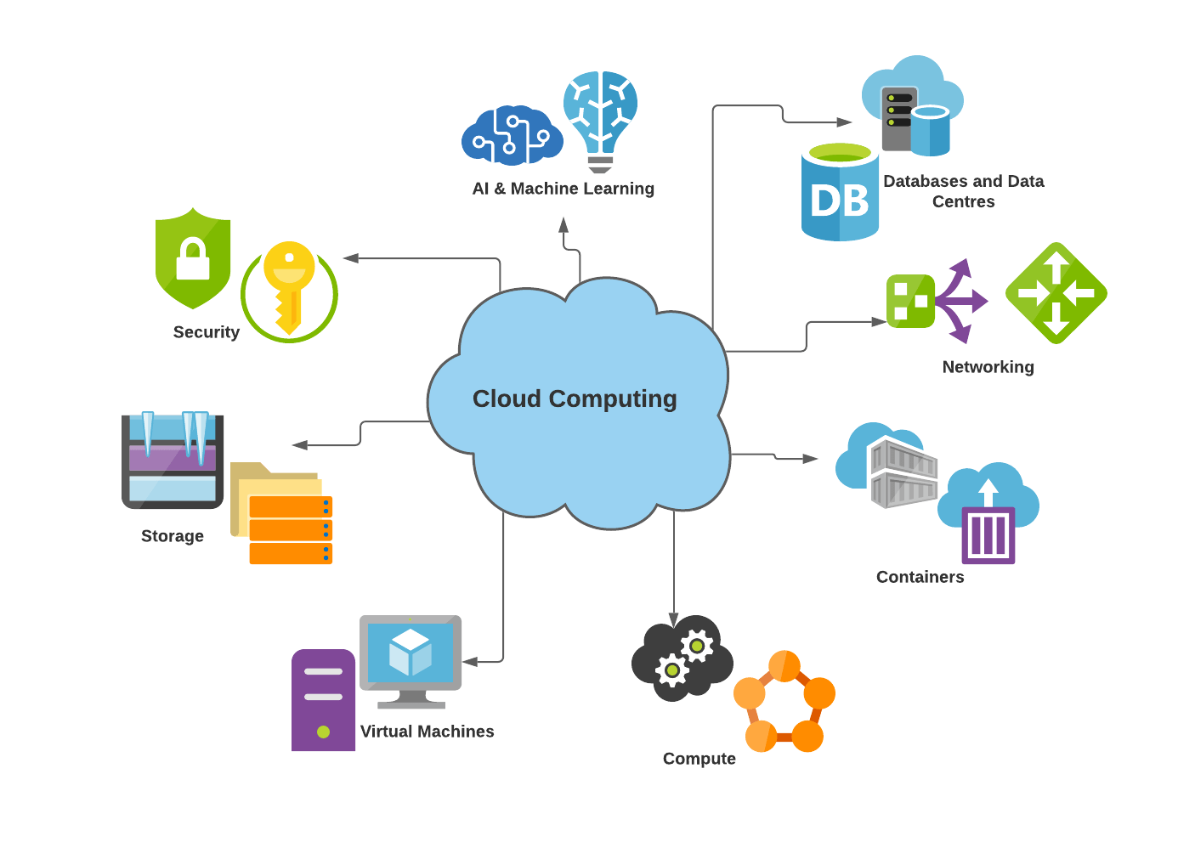
Key Features of Cloud Computing:
- On-Demand Self-Service: Users can provision computing resources such as virtual machines, storage, and applications without needing human intervention from the service provider.
- Broad Network Access: Cloud services can be accessed from any device that is connected to the internet.
- Resource Pooling: Cloud providers combine computing resources to serve multiple customers using a multi-tenant model, ensuring efficiency and cost-effectiveness.
- Rapid Elasticity: Resources can be automatically scaled up or down based on demand, providing flexibility and cost management.
- Measured Service: Cloud computing follows a pay-per-use model, where customers pay for the resources they consume.
Cloud computing models have quickly become a dominant force across industries, offering businesses the ability to scale their operations efficiently, access the latest technologies, and save costs on infrastructure.

2. Characteristics of Cloud Computing
Cloud computing is distinct from traditional IT infrastructure due to several key characteristics:

2.1 On-Demand Self-Service
Cloud computing allows users to provision and configure resources without direct human intervention. This self-service model enables users to scale services and applications as needed.

2.2 Broad Network Access
Cloud services are available over the internet, accessible from any device with a web browser, such as laptops, smartphones, and tablets. This makes it easier for users to access data and applications from anywhere.

2.3 Resource Pooling
Cloud providers use multi-tenant models to pool resources and dynamically allocate them to users as needed. The resources (computing, storage, and networking) are shared among multiple customers, reducing costs and improving resource utilization.

2.4 Rapid Elasticity
Cloud environments can quickly scale up or down based on demand. This elasticity ensures that users are only paying for what they use, without needing to over-provision infrastructure.

2.5 Measured Service
Cloud computing follows a utility-based pricing model where customers are billed based on their consumption. This ensures cost efficiency and allows for better resource management, reducing waste.

2.6 Security
Cloud providers ensure data security with built-in measures such as encryption, access control, firewalls, and intrusion detection systems. Cloud computing platforms typically offer higher levels of security than many organizations can afford on their own.

3. Types of Cloud Computing
Cloud computing services are generally categorized into two aspects: deployment models and service models.

3.1 Cloud Deployment Models
- Public Cloud:
  - The public cloud is owned and operated by a third-party provider, offering services to anyone who needs them. Resources like computing power, storage, and applications are shared with other customers. Examples: Amazon Web Services (AWS), Microsoft Azure, Google Cloud.
  - Advantages: Lower cost, ease of setup, no need for maintenance.
  - Disadvantages: Limited control, potential privacy concerns.
- Private Cloud:
  - A private cloud is dedicated to a single organization. It can be hosted on-premises or at a third-party provider's data center. This model offers more control and security.
  - Advantages: Greater control over security and data privacy, customizable.
  - Disadvantages: Higher costs, requires more management.
- Hybrid Cloud:
  - A hybrid cloud is a combination of public and private clouds, allowing data and applications to be shared between them. This provides businesses with more flexibility.
  - Advantages: Flexibility, scalability, and cost savings.
  - Disadvantages: Complexity in management, potential for data inconsistency.
- Community Cloud:
  - A community cloud is shared by several organizations with common interests or goals, such as regulatory requirements.
  - Advantages: Shared costs and resources.
  - Disadvantages: Less control, potential conflicts over resource use.
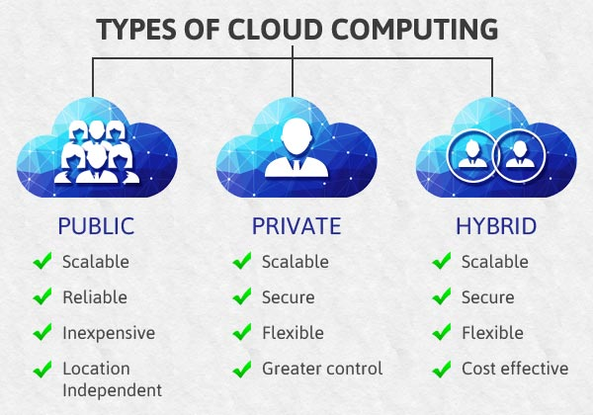

3.2 Cloud Service Models
- Infrastructure as a Service (IaaS):
  - IaaS provides virtualized computing resources over the internet. Users can rent virtual machines, storage, and networking, while the cloud provider manages the underlying infrastructure.
  - Examples: AWS EC2, Microsoft Azure Virtual Machines.
- Platform as a Service (PaaS):
  - PaaS offers a platform that allows users to build, deploy, and manage applications without worrying about the underlying infrastructure.
  - Examples: Google App Engine, Microsoft Azure App Services.
- Software as a Service (SaaS):
  - SaaS delivers software applications over the internet, removing the need for users to install, manage, or maintain them. The software is typically hosted on a remote server and accessed via a web browser.
  - Examples: Google Workspace, Salesforce, Dropbox.
- Function as a Service (FaaS):
  - FaaS is a serverless computing model that allows users to execute code in response to events. Users don’t have to manage servers, only the functions.
  - Examples: AWS Lambda, Google Cloud Functions.
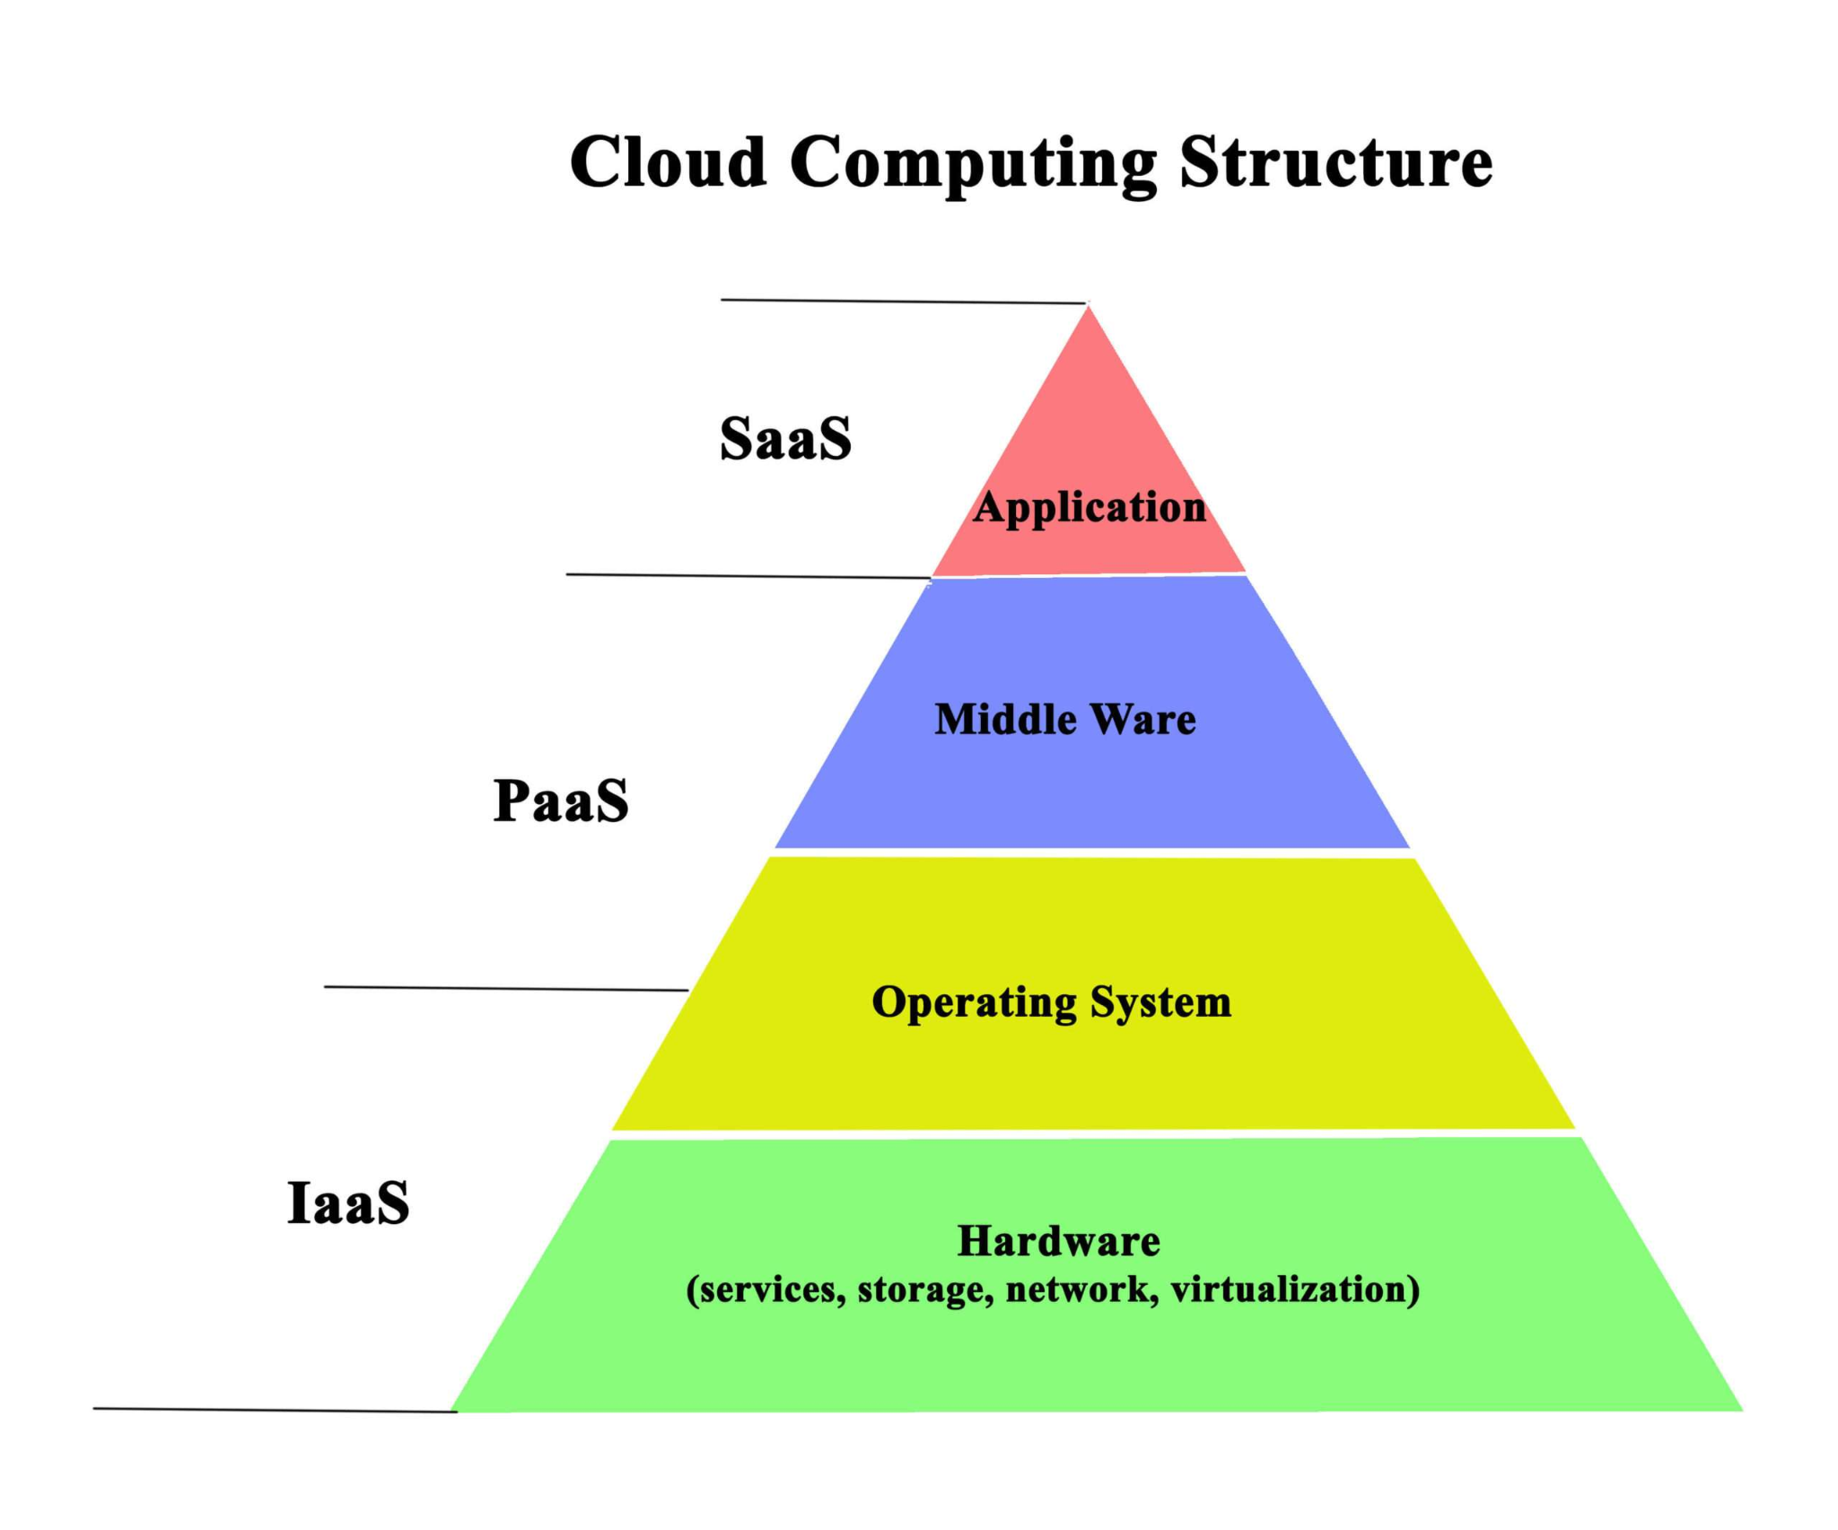

4. Advantages of Cloud Computing over Traditional IT Infrastructure

4.1 Cost Efficiency
Traditional IT:
- Organizations must purchase expensive physical hardware, such as servers, storage devices, and networking equipment. The upfront costs are high, and additional resources must be added as the business grows.
Cloud Computing:
- Cloud computing uses a pay-per-use model, where customers only pay for the resources they use. There are no large upfront investments in hardware or software, making it a more cost-effective option for businesses, especially small and medium-sized enterprises.

4.2 Scalability and Flexibility
Traditional IT:
- Scaling up or down with traditional IT infrastructure requires purchasing additional physical resources, which can be slow and costly. Businesses may also have to deal with overprovisioning, leading to wasted resources.

Cloud Computing:
Cloud platforms can scale resources up or down instantly, depending on demand. Businesses can easily adjust their resource usage without needing to invest in additional hardware.

4.3 Disaster Recovery and Business Continuity
Traditional IT:
- Implementing disaster recovery plans can be complex and costly. Organizations need to have backup servers, off-site storage, and dedicated personnel to handle recovery.
Cloud Computing:
- Cloud providers offer built-in disaster recovery solutions with high availability and failover mechanisms. Data is often replicated across multiple data centers, reducing the risk of data loss and minimizing downtime.

4.4 Global Accessibility
Traditional IT:
- With traditional IT infrastructure, resources are often limited to a specific physical location. Employees or customers in different regions may experience slow access to data and applications.
Cloud Computing: Cloud services are accessible from anywhere with an internet connection, allowing businesses to operate globally with minimal latency and better collaboration among remote teams.

4.5 Security and Compliance
Traditional IT:
- Organizations are responsible for securing their own data, which can be expensive and complex. Managing access controls, firewalls, and encryption systems requires dedicated resources.
Cloud Computing:
- Cloud providers invest heavily in security measures such as encryption, multi-factor authentication, and identity management systems. Many cloud providers also comply with international standards and regulations, such as GDPR, HIPAA, and ISO 27001.

5. Cloud Computing Concepts in Detail

5.1 Virtualization
Virtualization is a foundational technology in cloud computing. It allows cloud providers to run multiple virtual machines (VMs) on a single physical machine. This reduces hardware costs and improves resource utilization.

5.2 Elasticity

Elasticity refers to the cloud’s ability to automatically scale resources up or down based on demand. For example, during periods of high demand, such as holiday shopping seasons, cloud services can automatically allocate more computing resources.

5.3 Containers and Microservices
- Containers: Containers are lightweight, portable environments that encapsulate an application and its dependencies. They allow for easier deployment and scaling of applications in the cloud.
- Microservices: Microservices architecture breaks down applications into smaller, independently deployable services that can be developed, deployed, and scaled individually.

5.4 Serverless Computing
Serverless computing allows developers to write code that automatically executes in response to events, without managing the underlying infrastructure. This model reduces overhead and complexity, letting developers focus on writing code rather than managing servers.

6. Case Study: Cloud Computing in E-Commerce

6.1 Background
An e-commerce company struggled with maintaining a stable website during high-traffic periods like Black Friday. The company’s on-premise infrastructure couldn’t handle the increased demand, leading to website downtime and lost sales.

6.2 Traditional IT Infrastructure
- The company used physical servers and required manual intervention to scale resources during high traffic.
- Servers were often underutilized during low-demand periods, leading to inefficiencies and wasted resources.

Conclusion
Cloud computing has fundamentally transformed the way businesses manage their IT resources, offering significant advantages over traditional infrastructure. Its flexibility, scalability, cost-effectiveness, and global accessibility make it an ideal solution for organizations looking to optimize operations, reduce overhead costs, and improve service delivery. By utilizing cloud services, businesses can scale efficiently, enhance security, and leverage advanced technologies without the need for extensive upfront investment or maintenance.
As industries continue to evolve, the cloud's role in fostering innovation and improving operational efficiency will only increase. Whether through enhancing collaboration, improving disaster recovery, or streamlining resource management, cloud computing is paving the way for a more dynamic and agile future in business and technology.

